**FH2021 (MCQS and Subjective)**

**Q Solve any two out of three.**

1. What is an Intelligent Agents? Discuss the types of Agents. **(10m)** (Module 1)
2. Explain in detail the BFS and DFS with suitable example. **(10m)** (Module 2)
3. Discuss in detail the Perceptron Networks and calculate the net input *( yin )* of the given network. **(10m)** (Module 3)

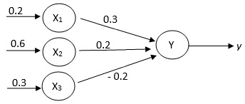

**Q Solve any two out of three.**

1. Explain Random Forest in detail with suitable example. **(10m)** (Module 5)
2. What is Kernel Machines? Discuss in detail Support Vector Machine. **(10m)** (Module 6)
3. Apply the Naive Bayes Classifier on given Training Dataset and identify the given data (X) belongs to the class Buys Computer = Yes or Buys Computer = No.Data to be classified: **(10m)** (Module 4)

X= (age <=25, Income = Medium, Student = Yes, Credit Rating = Fair)

Training Dataset:

|  |  |  |  |  |
| --- | --- | --- | --- | --- |
| Age | Income | Student | Credit Rating | Buys Computer |
| <=25 | Max | No | Fair | No |
| <=25 | Max | No | Very Good | No |
| 26 to 35 | Max | No | Fair | Yes |
| >35 | Medium | No | Fair | Yes |
| >35 | Min | Yes | Fair | Yes |
| >35 | Min | Yes | Very Good | No |
| 26 to 35 | Min | Yes | Very Good | Yes |
| <=25 | Medium | No | Fair | No |
| <=25 | Min | Yes | Fair | Yes |
| >35 | Medium | Yes | Fair | Yes |
| <=25 | Medium | Yes | Very Good | Yes |
| 26 to 35 | Medium | No | Very Good | Yes |
| 26 to 35 | Max | Yes | Fair | Yes |
| >35 | Medium | No | Very Good | No |

**FH2022 (MCQS and subjective)**

**Q Solve any two out of three.**

1. Explain K-Means clustering algorithm with proper steps. **(10m)** (Module 4)
2. Describe principal Component analysis with suitable examples. **(10m)** (Module 7)
3. Explain any two types of agents with architecture. **(10m)** (Module 1)

**Q Solve any two out of three.**

1. Use A* algorithm to find the path and cost from start state (S) to goal state (G). **(10m)** (Module 2)

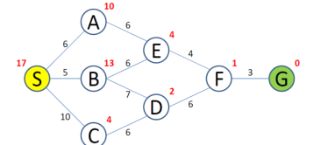

1. Explain Logistic Regression in detail with suitable examples. **(10m)** (Module 5)
2. Explain the basic ID3 algorithm of the decision tree and find out which attribute is the best classifier from the following dataset for the target attribute buys computer. (10m) (Module 4).

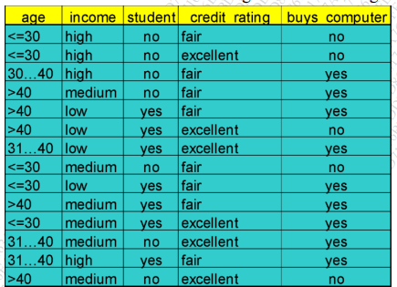

**Q Solve any two out of three.**

1. Describe the support vector machine with advantages and disadvantages. **(10m)** (Module 6)
2. Describe Bayesian networks with suitable example. **(10m)** (Module 5)
3. Explain random forest algorithm in detail with steps. **(10m)** (Module 5)

**FH2023 (Subjective)**

**Q Write a short note on any four**

1. Agent Environment types **(5m)** (Module 1)
2. K-Nearest Neighbour Classifier **(5m)** (Module 4)
3. Types of Activation function **(5m)** (Module 3)
4. Linear Discriminant Analysis **(5m)** (Module 7)
5. Bagging and boosting **(5m)** (Module 6)

**Q Attempt any three of the questions**

Q2 (a) What are the different types of Agents? Explain PEAS representation of an Agent. **(10m)** (Module 1)

(b) Discuss various search strategies and explain the un-informed Search. **(10m)** (Module 2)

Q3 (a) What is the inference in first order logic? Explain with suitable examples. **(10m)** (Module 1)

(b) For the network shown in the figure, calculate the net input to the output neuron. **(10m)** (Module 3)

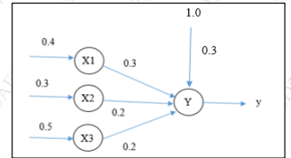

Q4 (a) What is the application of machine learning? Explain the supervised learning. **(10m)** (Module 4)

(b) Desvribe Adaline network with a neat diagram. **(10m)** (Module 3)

Q5 (a) Disvuss in detail the Random Forest and define the term Bias and variance. **(10m)** (Module 5)

(b) Explain the Support vector machine (SVM) in detail with the example. **(10m)** (Module 6)

Q6 (a) Describe in detail the Bayesian Belief network with an example. **(10m)** (Module 5)

(b) Compare Feature Extraction and Feature Selection techniques. Explain how dimensionality can be reduced using Principal Component Analysis. **(10m)** (Module 7 Self Study topic)

**SH2021 SEM2 ATKT (MCQS and Subjective)**

**Q Solve any four out of six.**

1. What is entropy and what is its significance? **(5m) (Module 4)**
2. What are Steps for Designing Learning System.? **(5m)**
3. Write a short note on KNN Classification. **(5m) (Module 4)**
4. Give a PEAS representation for an intelligent Robot for cleaning a library. **(5m)** (Module1)
5. Write a note on Support Vector Machine. **(5m)** (Module 6)
6. Explain any method of reducing dimensionality? **(5m)** (Module 7)

**Q Solve any two questions out of three**

1. Explain Hill Climbing Searching Technique with its advantages and limitations. **(10m)** (Module 2)
2. Explain the K-Means Clustering algorithm with an example. **(10m)** (Module 4)
3. Implement AND function using perceptron network for bipolar inputs and bipolar targets.(Initial values are w1=w2=w3=b=0, learning rate=1, threshold=0.2) **(10m)** (Module 3)

**SH2022/FH2023? SEM2 ATKT / 28/2/2023**

* + - 1. Bias / Variance tradeoff **(5m)** (Module 5)
      2. Intelligent Agent **(5m)** (Module 1)
      3. PCA **(5m)** (Module 7)
      4. Activation Function **(5m)** (Module 3)

Q Attempt any three out of five

Q2 (a) Explain expectation-maximization algorithm with an example. **(10m)** (Module 5)

(b) Discuss Dimensionality Reduction in detail. **(10m)** (Module 7)

Q3 (a) Explain k-nearest neighbour algorithm with an example. **(10m)** (Module 4)

(b) Explain support vector machine in detail. **(10m)** (Module 6)

Q4 (a) Discuss Perceptron algorithm with a neat flowchart. **(10m)** (Module 3)

(b) Explain First Order logic with example. **(10m)** (Module 1)

Q5 (a) Explain A* algorithm with a suitable example. **(10m)** (Module 2)

(b) Explain Adaline neural network with an example. **(10m)** (Module 3)

Q6 (a) Discuss Alpha Beta search algorithm with suitable example. **(10m)** (Module 2)

(b) Explain Random Forest algorithm in detail. **(10m)** (Module 5)

**SH2023 DECEMBER (Subjective)**

**Q Write a short note on any four**

1. What are applications of Machine Learning? [5M] (Module 4)
2. Explain the algorithm for Support Vector Machines? [5M] (Module 6)
3. Write the characteristics of problems? [5M] (Module 1)
4. Explain Artificial Neural Network architecture in brief? [5M] (Module 3)
5. What are advantages of K-Nearest Neighbor? [5M] (Module 4)

**Q Attempt any three of the questions**

Q2

a) Explain what are steps for PCA algorithm in detail? [10M] (Module 7)

b) Write short note on “Clustering approaches”. [10M] (Module 5)

Q3

a) Explain Heuristic Search Techniques in detail? [10M] (Module1)

b) Explain the Expectation-Maximization algorithm in detail? [10M]

(Module 5)

Q4

a) Explain the types of Hill Climbing in heuristic search? [10M] (Module 2)

b) Write short note on “Random Forest”. [10M] (Module 5)

Q5

a) Explain the types of Gradient Descent Optimization Algorithm in detail? [10M]

(Module 3)

b) Explain the architecture of intelligent agents? [10M](Module 1)

Q6

a) Explain the Gaussian Mixture Model in detail? [10M] (Module 6)

b) Explain the types of Reasoning In artificial intelligence in detail? [10M] (Module 1)

c) Explain what steps for implementing the Adaboost Algorithm in detail [10M] (Module 6)